Module(BOOTSTRAP BASIC AND ADVANCE)-6

1.What are the advantage of bootstrap?

* Speedy Development: Bootstrap’s ready-made components accelerate development, enabling faster project completion.
* Responsive by Design: It provides built-in grid system.
* Flexible Customization: Customizable themes, variables, and mixins provide flexibility to match specific project requirements and branding.
* Community Support: Being open-source, Bootstrap benefits from a robust community, offering resources, documentation, and third-party plugins.

2.What is Bootstrap Container and how does it work?

* Containers are the most basic layout element in Bootstrap and are required when using our default grid system.
* Containers are used to contain, pad, and (sometimes) center the content within them.
* While containers can be nested, most layouts do not require a nested container.

3.What are the default Bootstrap text setting?

* Bootstrap 4 uses a default font-size of 16px, and its line-height is 1.5.
* The default font-family is "Helvetica Neue", Helvetica, Arial, sans-serif.
* In addition, all <p> elements have margin-top: 0 and margin-bottom: 1rem (16px by default).

4.What do you know about the Bootstrap Grid System?

* Bootstrap’s grid system uses a series of containers, rows, and columns to layout and align content.
* It’s built with flexbox and is fully responsive.
* Bootstrap's grid system allows up to 12 columns across the page.
* Bootstrap's grid system is responsive, and the columns will re-arrange depending on the screen size

5.What is a Button Group, and what is the class for a basic Button Group?

* Bootstrap allows you to group a series of buttons together (on a single line) in a button group.
* Use a <div> element with class .btn-group to create a button group.

6.How can you use Bootstrap to make thumbnails?

* A thumbnail is a small image that represents a larger image.
* To create thumbnails using Bootstrap –
* Add an <a> tag with the class of **.thumbnail** around an image.
* This adds four pixels of padding and a gray border.
* On hover, an animated glow outlines the image.
* <img src="..." alt="..." class="img-thumbnail">

7.In Bootstrap 4, what is flexbox?

* The biggest difference between Bootstrap 3 and Bootstrap 4 is that Bootstrap 4 now uses flexbox, instead of floats, to handle the layout.
* Use flex classes to control the layout of Bootstrap 4 components.
* The Flexible Box Layout Module, makes it easier to design flexible responsive layout structure without using float or positioning.

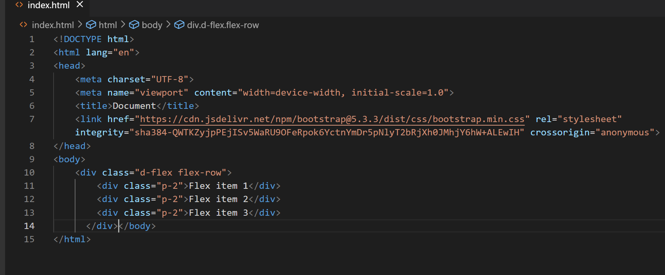

8.How can one create an alert in Bootstrap?

* Bootstrap provides an easy way to create predefined alert messages
* Alerts are created with the .alert class, followed by one of the four contextual classes .alert-success, .alert-info, .alert-warning or .alert-danger
* Example:

<div class="alert alert-success">

<strong>Success!</strong> Indicates a successful or positive action.

</div>

* Alert Links:
* Add the alert-link class to any links inside the alert box to create "matching colored links"
* Closing Alerts:
* To close the alert message, add a .alert-dismissible class to the alert container. Then add class="close" and data-dismiss="alert" to a link or a button element (when you click on this the alert box 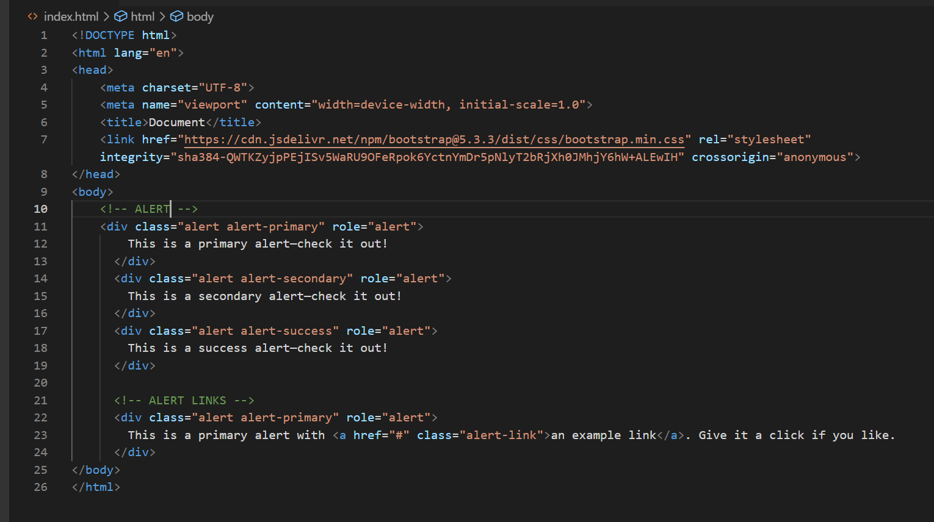will disappear).

9.What is Bootstrap card and how would you create one?

* A card is a flexible and extensible content container.
* It includes options for headers and footers, a wide variety of content, contextual background colors, and powerful display options

